Ramadan Prompting

Nights
Scenario-based prompting competition. 30 nights. 30 real-world coding scenarios.
by Sir Asharib Ali · for GIAIC Students

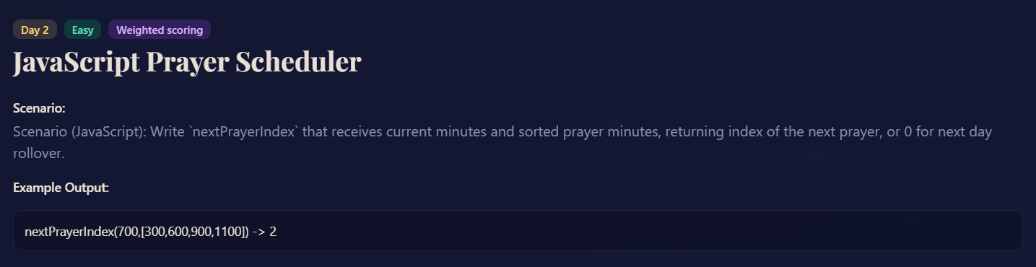

PROMPT:
Goal: Write a JavaScript function nextPrayerIndex (currentMinutes, prayerMinutes) that returns the index of the next prayer based on the current time in minutes. If the current time is past all prayer times, the function should return 0 for the next day rollover.
Constraints:
1. currentMinutes is an integer between 0 and 1439 (representing minutes from 00:00 t0 23:59)
2. prayerMinutes is a sorted array of integers in ascending order, each between 0 and 1439.
3. Array length ≥ 1 (at least one prayer time)
Edge Cases:
1. currentMinutes is before the first prayer -> return index 0.
2. currentsMinutes is after the last prayer -> return index 0 (next day rollover).
3. currentMinutes matches exactly a prayer time -> return index of that prayer.
4. Only 1 prayer in the array -> always return index 0.
Output Format: Return a single integer representing the index of the next prayer in the prayerMinutes array.
Example:
nextPrayerInsex(700, [300, 600, 900, 1100]) // returns 2
nextPrayerIndex(1200, [300, 600, 900, 1100]) // returns 0

